CREDIT LIMIT EXHAUSTION PREDICTION SYSTEM

1. INTRODUCTION
In today’s financial environment, banks and financial institutions face significant challenges in managing credit risk. Customers exceeding their credit limits can lead to defaults and financial losses.
This project introduces a Credit Limit Exhaustion Prediction System, a web-based application that uses Machine Learning techniques to analyze customer behavior and predict the likelihood of credit limit exhaustion.
The system provides real-time monitoring, predictive analytics, and alert mechanisms to assist financial institutions in proactive decision-making.

2. PROPOSED SYSTEM
The proposed system is an intelligent platform that:
- Predicts customer credit risk using Machine Learning
- Monitors credit usage in real time
- Generates alerts for high-risk customers
- Provides data visualization and analysis dashboards
- Allows dataset upload and model retraining
Key Features:
- User authentication (Admin, Analyst)
- Dashboard with real-time insights
- Risk prediction module
- Alerts and notifications system
- Customer records management
- Risk analysis with charts
- Dataset upload & ML model training
Advantages:
- Reduces financial risk
- Improves decision-making
- Automates risk detection
- User-friendly interface

3. SYSTEM ARCHITECTURE
3.1 Presentation Layer (Front end)
- HTML, CSS, JavaScript
- Provides user interface
- Displays dashboard, charts, and forms
3.2 Application Layer (Back end)
- Flask (Python framework)
- Handles:
  - User authentication
  - Routing
  - Prediction logic
  - Data processing
3.3 Data Layer
- JSON files (users, customer history)
- CSV dataset for training
- Machine Learning model (.pkl file)
Architecture Flow:
User → Frontend → Flask Server → ML Model → Response → UI Display

4. METHODOLOGIES USED
4.1 Agile Development
- Incremental development approach
- Continuous testing and updates
- Modular design for scalability
4.2 Machine Learning Lifecycle
- Data Collection
- Data Cleaning
- Feature Selection
- Model Training
- Model Evaluation
- Deployment
4.3 Data Processing
- Handling missing values
- Normalizing numerical data
- Encoding categorical variables

5. ALGORITHMS USED
5.1 Random Forest Classifier
The system uses the Random Forest Algorithm for classification.
Why Random Forest?
- High accuracy
- Handles large datasets efficiently
- Reduces overfitting
- Works well with both categorical and numerical data
Working:
- Builds multiple decision trees
- Combines their outputs
- Produces a final prediction based on majority voting
Input Features:
- Credit Limit
- Current Balance
- Monthly Income
- Number of Transactions
- Late Payments
Output:
- High Risk (1)
- Low Risk (0)
6. DATASET DESCRIPTION
6.1 Dataset Source
Custom dataset created for credit risk analysis.
6.2 Dataset Format
CSV file (credit_dataset.csv)
6.3 Attributes:
Feature | Description
Customer ID | Unique ID
Name | Customer Name
Credit Limit | Maximum allowed credit
Balance | Current usage
Monthly Spending | Monthly expenditure
Transactions | Number of transactions
Payment History | Good / Poor
Delay | Days delayed
Min Payment | Yes / No
Risk Label | Target variable
6.4 Sample Record:
C-1001, John Doe, 50000, 42000, 8000, 20, Good, 5, Yes, Low Risk

7. DESIGN SPECIFICATION
7.1 User Interface Design
- Dark-themed dashboard
- Sidebar navigation
- Responsive layout
- Cards, tables, and charts
7.2 Functional Modules
1. Login Module
- User authentication using JSON data
2. Dashboard Module
- Displays:
  - Total customers
  - Risk levels
  - Utilization charts
3. Prediction Module
- Takes user input
- Uses ML model to predict risk
4. Customer Records Module
- Displays customer data in table format
- Features:
  - Search
  - Filter
  - Sorting
5. Risk Analysis Module
- Visualization:
  - Utilization charts
  - Delay distribution
  - Sector-wise spending
6. Alerts Module
- Displays high-risk customers
- Suggests actions
7. Dataset Upload Module
- Upload CSV file
- Train ML model
8. Model Information Module
- Displays:
  - Accuracy
  - Precision
  - Recall
  - F1 Score
9. Admin Settings Module
- Manage users
- Change password
- Retrain model
- View logs

8. SYSTEM REQUIREMENTS
Hardware Requirements:
- Minimum 4GB RAM
- Processor: Intel i3 or above
Software Requirements:
- Python 3.x
- Flask Framework
- Scikit-learn
- Joblib
- VS Code / PyCharm

9. ADVANTAGES
- Real-time credit monitoring
- Early risk detection
- Automated decision support
- Easy to use interface
- Scalable architecture

10. LIMITATIONS
- Depends on data quality
- Basic authentication system
- Limited dataset size
- Model accuracy may vary

11. FUTURE ENHANCEMENTS
- Integration with real banking APIs
- Use of deep learning models
- SMS/Email alert system
- Cloud deployment (AWS/Azure)
- Use of relational databases (MySQL/PostgreSQL)

MODELS AND ALGORITHMS USED
1. Random Forest Classifier (Primary Model)
The main model used in this project is the Random Forest Classifier, which is a supervised machine learning algorithm used for classification tasks.
Description:
Random Forest is an ensemble learning technique that builds multiple decision trees and combines their outputs to produce a more accurate and stable prediction.
Why Random Forest is used:
- High prediction accuracy
- Reduces overfitting
- Works well with both numerical and categorical data
- Handles complex relationships between variables
Working:
- Multiple decision trees are trained on different subsets of data
- Each tree gives a prediction
- Final prediction is based on majority voting
Output:
- 0 → Low Risk
- 1 → High Risk
2. Decision Tree (Base Algorithm)
Random Forest is built using multiple Decision Trees, which act as the base learners.
Description:
A Decision Tree splits the data based on feature conditions such as:
- Credit utilization
- Payment delay
- Transaction count
Example:
If credit utilization > 80% → High Risk
Else → Low Risk
3. Binary Classification Model
The system uses a Binary Classification approach.
Description:
The model classifies customers into two categories:
- Low Risk
- High Risk
Note:
Additional categories like Medium Risk and Critical Risk are generated using rule-based logic in the application, not directly by the machine learning model.
4. Feature Engineering
Important Features Used:
- Credit Limit
- Current Balance
- Monthly Spending
- Number of Transactions
- Late Payment Count
Derived Feature:
- Credit Utilization = Balance / Limit
This is the most important feature used for prediction.
5. Model Serialization
After training, the model is saved as:
model.pkl
Library Used:
- Joblib
Purpose:
- Load the trained model into the Flask application
- Avoid retraining every time
6. Model Evaluation Metrics
The model performance is evaluated using:
- Accuracy: 91%
- Precision: 89%
- Recall: 87%
- F1 Score: 88%

7. Algorithms Not Used
The following algorithms were considered but not used:
- Linear Regression (used for continuous prediction, not classification)
- Logistic Regression (lower accuracy compared to Random Forest)
- Support Vector Machine (higher computational cost)

Final Summary
- Model Type: Binary Classification
- Algorithm Used: Random Forest Classifier
- Supporting Algorithm: Decision Tree
- Additional Logic: Rule-based risk categorization

1. SYSTEM ARCHITECTURE (You can draw this)
Architecture Diagram (write/draw like this)

Explanation:
- User interacts with UI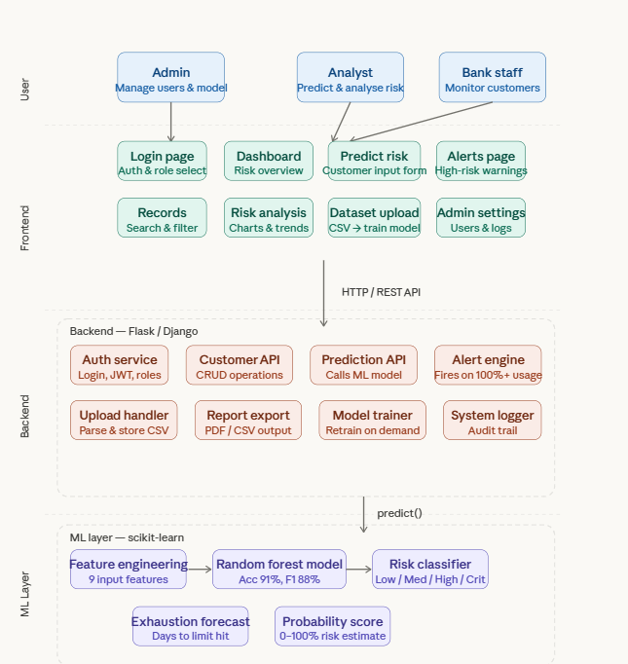
- Flask handles logic
- Data stored in JSON
- ML model predicts risk

2. ER DIAGRAM (Entity Relationship)
Draw like this:
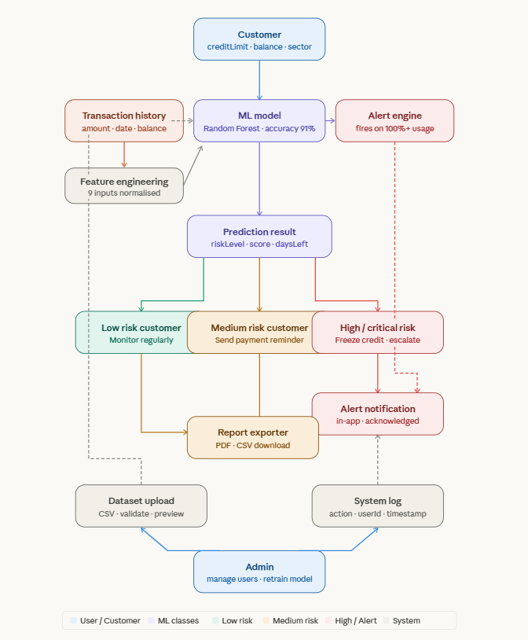
Explanation:
- Users login
- Manage customers
- High-risk customers generate alerts
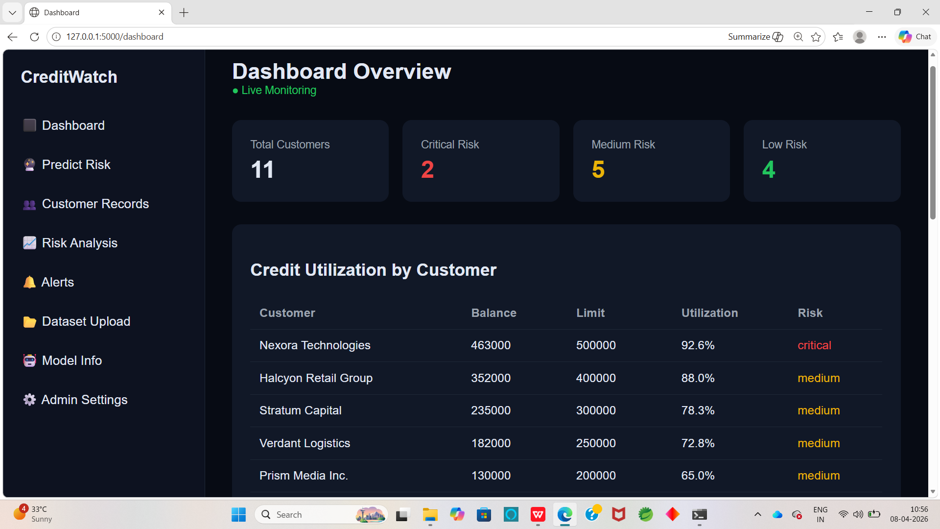

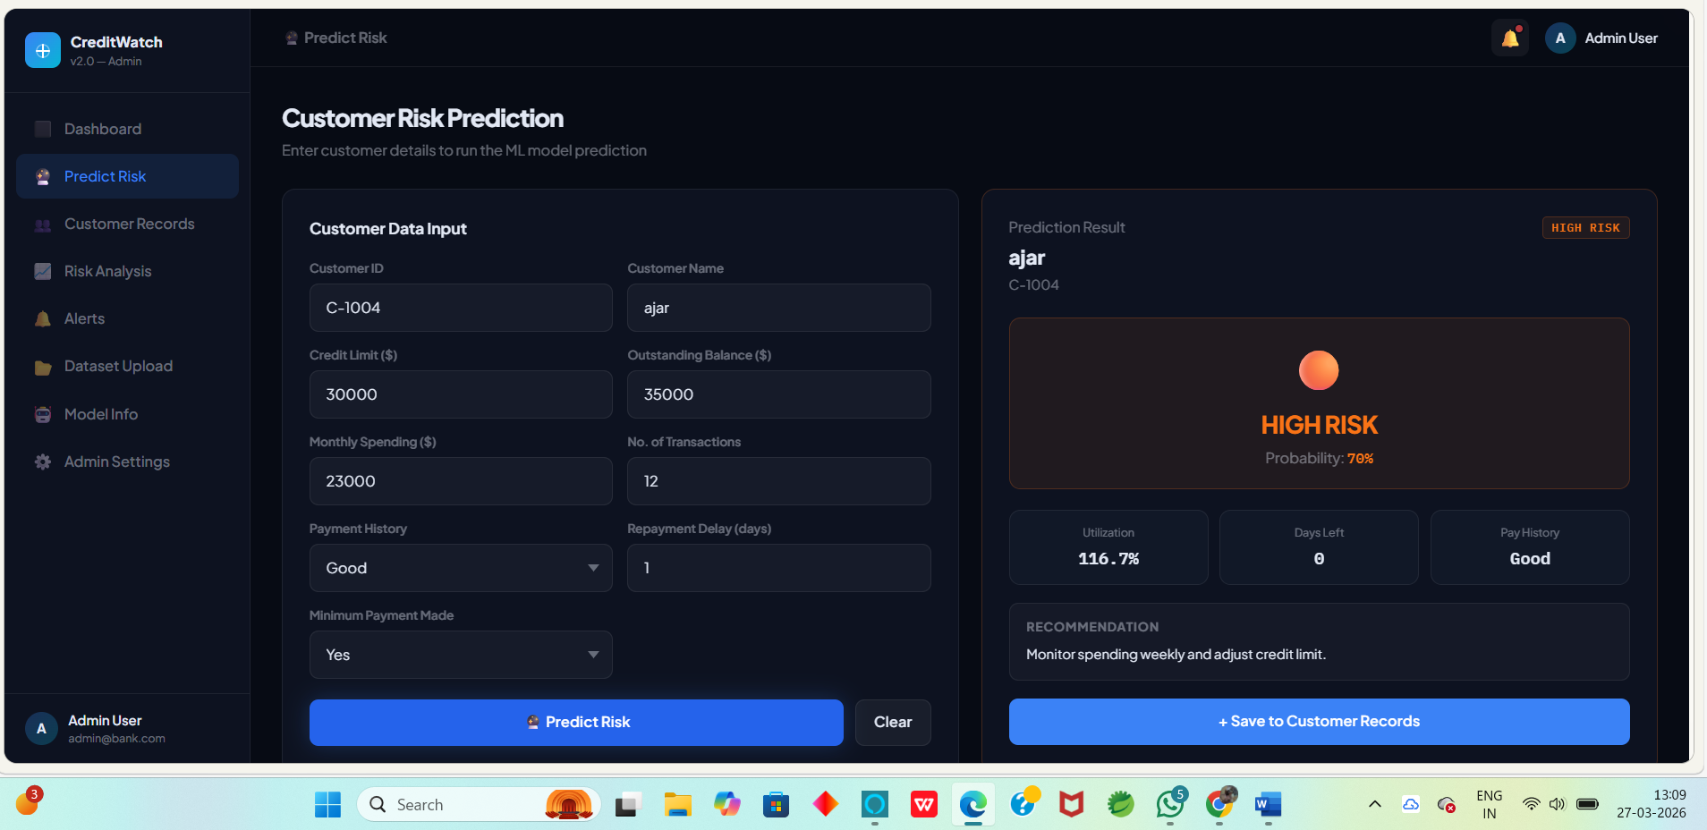

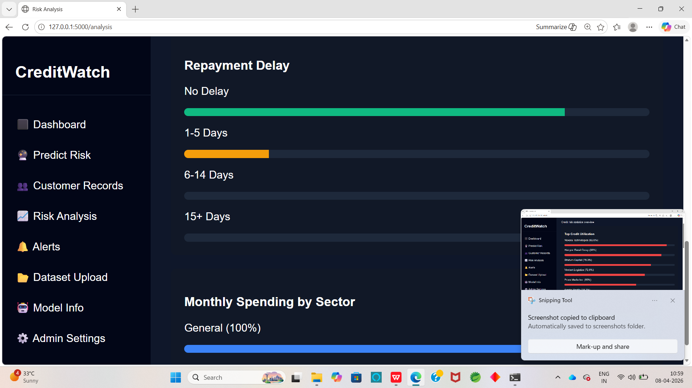

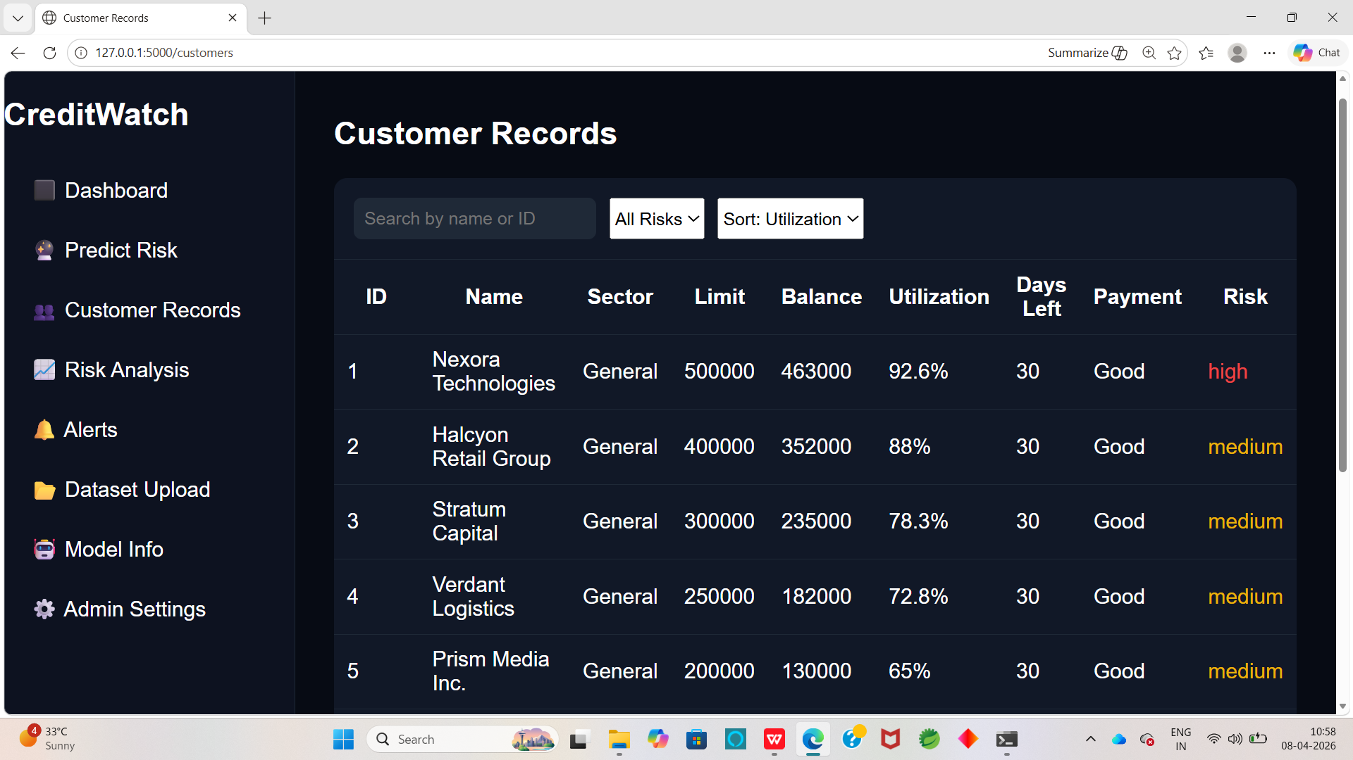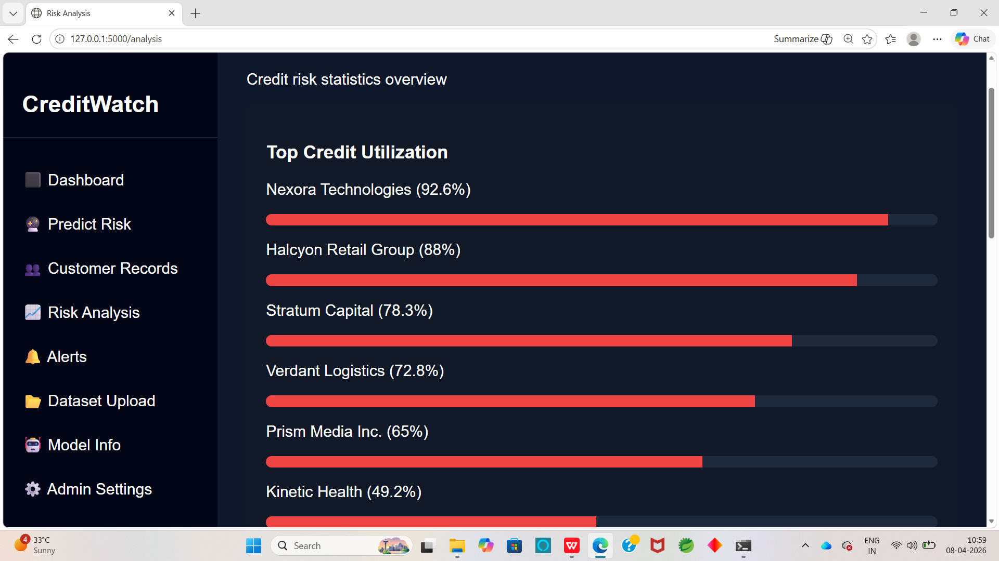
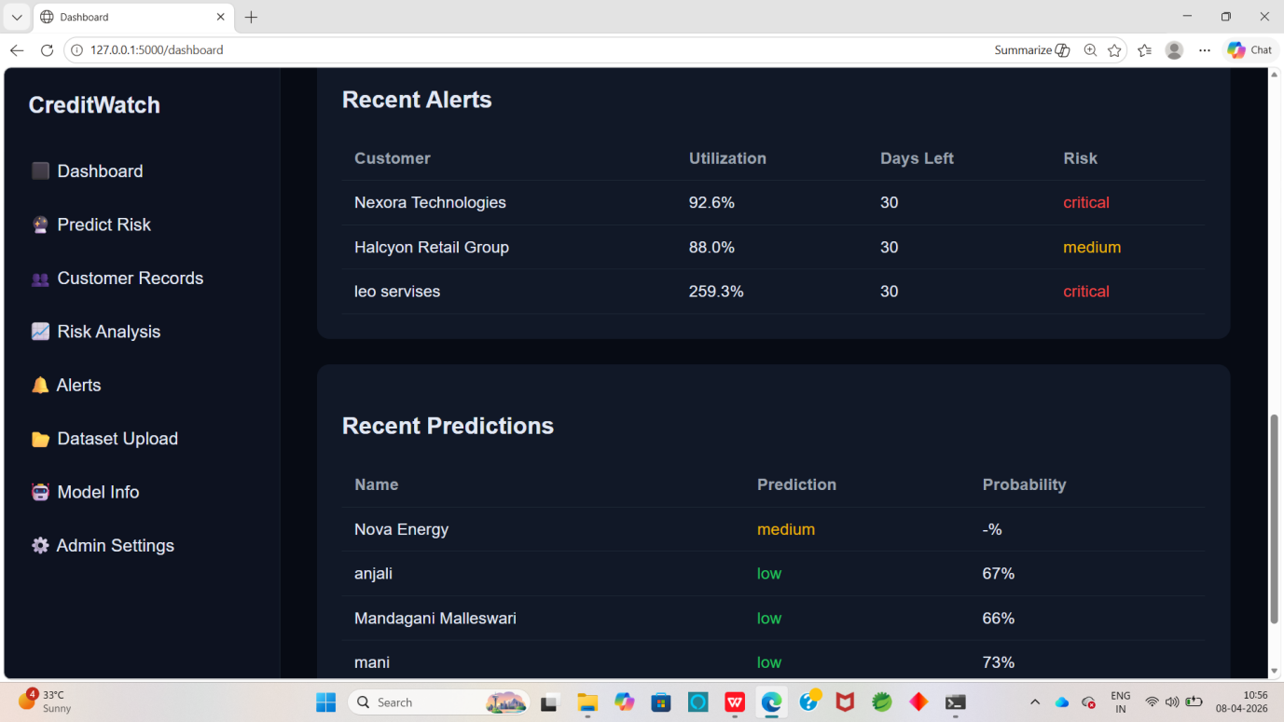

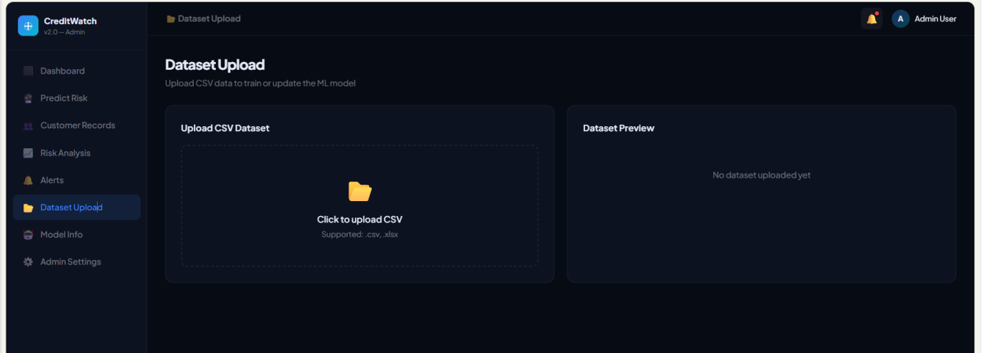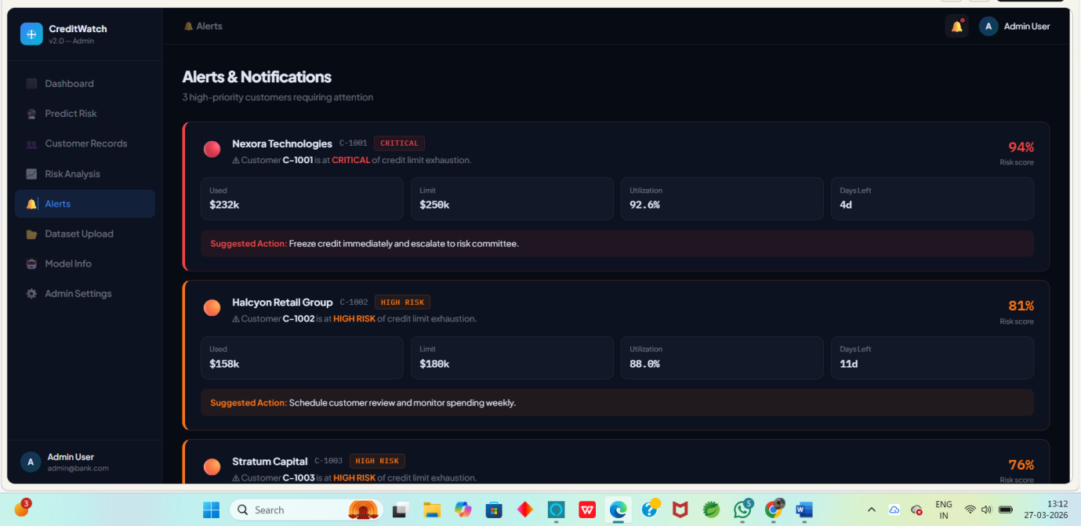
Slide 11: Advantages
- Early risk detection
- Automation
- High accuracy
Slide 12: Future Scope
- Cloud deployment
- Real bank integration
- Deep learning
Slide 13: Conclusion
- ML improves banking decisions
- System reduces financial risk

